7.1.9 Editors - 3D View - Tool Shelf - Surface - Edit Mode
Tool Shelf - Surface - Edit Mode 2
Select, 3D Cursor, Transform, Measure and Annotate tools 2

Tool Shelf - Surface - Edit Mode
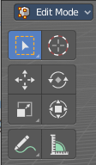
The tool shelf does not have any tools in the tool shelf yet for the Surface object.

Select, 3D Cursor, Transform, Measure and Annotate tools
The Select , 3D Cursor, Transform, Measure and Annotate tools at the end of the list are explained in the chapter 7.1.1 Editors - 3D View - Tool Shelf - Object Mode. We won't cover this tools again here.

